OFFICIAL LEAGUE ROSTER – BASKETBALL

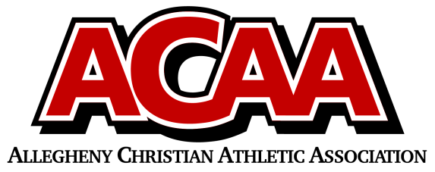

School Name: **BELLEVILLE MENNONITE**

Opponent:

Date:

| **Number** | **Name** | **Year** | **Position** | **Height** |
| --- | --- | --- | --- | --- |
|  |  |  |  |  |
|  |  |  |  |  |
|  |  |  |  |  |
| 2 | Clay Ammon | 12 |  |  |
| 31 | Paul Yoder | 12 |  |  |
| 5 | Dakota Gibbons | 11 |  |  |
| 4 | Bryson Peachey | 11 |  |  |
| 50 | Ethan Renno | 10 |  |  |
| 51 | Colin Hartzler | 10 |  |  |
| 54 | Grant Yoder | 10 |  |  |
| 15 | Landon Rhodes | 10 |  |  |
| 24 | Eli Henderson | 9 |  |  |
| 43 | Ian Kauffman | 9 |  |  |
| 22 | Bailey Armstrong | 9 |  |  |
| 53 | Devin Yoder | 9 |  |  |
| 23 | Landon Yoder | 9 |  |  |
|  |  |  |  |  |
|  |  |  |  |  |
|  |  |  |  |  |
|  |  |  |  |  |
|  |  |  |  |  |
|  |  |  |  |  |
|  |  |  |  |  |
|  |  |  |  |  |
|  |  |  |  |  |

Head Coach: **Chase Peachey**

Asst. Coach: **Mike Ammon**

Asst. Coach:

*Official ACAA League Team Roster - to be submitted to the scorer’s table before each game.*